

Web

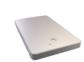Led TvSurface Pro - BurgundySurface Pro - Burgundy

Web

Rest API

Web API

API

Web Services

Da

Web